1900-1909
Life in 1900-1909
Church was in, sitting in your Sunday best…no TV or radio. God didn’t have any
competition.
Autograph Books were popular with girls, messages and funny poems or limericks inside them.
The fashion of at the turn of the century was formal and romantic.
Women wore the high, straight-front corset with long hips making the waist as small as possible.
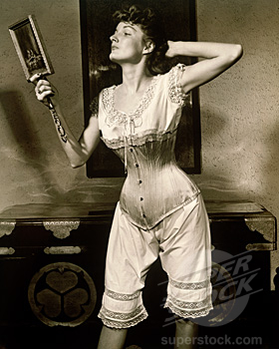
Garters came in during this decade. The skirt grew shorter to accommodate stepping onto the new automobile.
Hats were large. People were very clothes conscious and clothes were 'costumy'.
Ladies wore Ostrich feathers in their hats 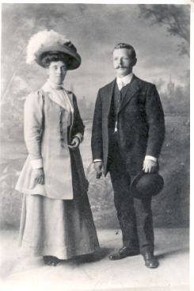
- Gloves had to be long enough to cover upper arms (Bare flesh drove men wild!!!)
- Pearls were the jewelry of the decade 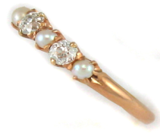

Timeline Prewar
1900
Box Camera Invented
Plasticine invented by William Harbutt
Nester publishes first pop up book type called Wonderland
Sigmund Freud’s Interpretation of dreams published
Button down shirt introduced
First hamburger 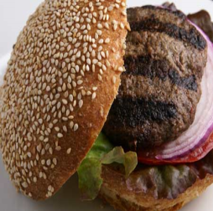
Dwight Davis establishes Davis Cup for tennis.
Lyman Franks Baum’s Wonderful World of Oz

`
1901
Frank Hornby invents Mechano 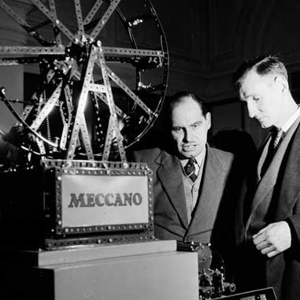
Queen Victoria dies
Chekhov’s three sisters
Gramophone records make their debut
Nickelodeons first cinemas
First fingerprint system invented
Wireless telegraphy messages sent across Atlantic by G Marconi
Edward Prescott builds Loop-the-Loop Roller Coaster at Coney Island
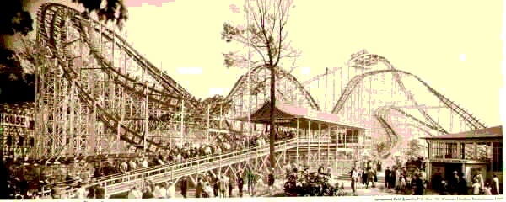
1902
Joseph Conrad’s Heart of Darkness novel
Pepsi Cola founded (USA) 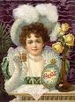
First SCI-FI film A trip to the moon by G Me’li’es (France)
Beatrix Potters Peter Rabbit 
Edison invents the battery. 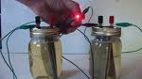
Marmite introduced to the world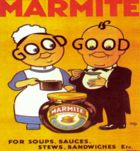

1903
The first Toy Fair was held
The birth of the The Humpty Dumpty toy Circus
Kenton makes cast iron toy cars the “Red devil”
Jack London’s Call of the Wild novel
First Harley Davison Motorcycle built (USA) 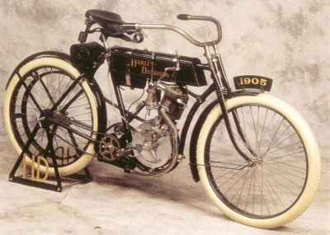
The Ford Company The Model T car made motoring affordable
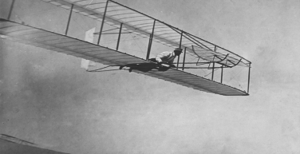 Wright Brothers flight17 Dec

Gillette King Camp Gillette Blade starts.
Teddy’s bears toys introduced
Crayola crayons
1904
John Fleming invents radio valve
US newspaper carries 22 March first colour photo’s
First Ice Cream cones invented Italo Marcioni

21 Jul Rigolly (FRANCE) became the first man to drive over 100 mph (160kph)
Olympics: Marathon runner Fred Lorz cheats race using a friend’s car

1905
Einstein’s special and general relativity theory.
First pre selective jukebox (USA)
Nickelodeon cinema popular
Pizza Italian dish makes debut in New York City 
Cadbury’s produces Cadbury’s dairy milk chocolate.
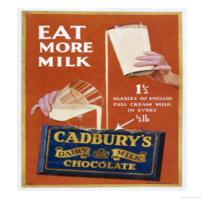

1906
First Grand Prix motorcar race held, near Le Mans (FRANCE)
Kellogs cereal company founded
The Thomas A. Edison produced first audio comer

1907
Lee DeForest became first disc jockey
The feather boa was all the rage. 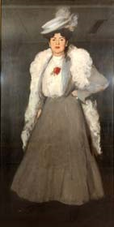
First regular radio broadcast by De Forest Radio telephone co (USA)
Bakelite forerunner of plastic introduced 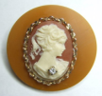
First prototype helicopter invented by French Paul Cornu

Cracker Jacks introduces packing toys into food.
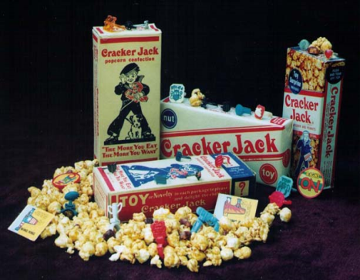
1908
Jack Johnson (USA) became first Black heavyweight boxing champion
Hoover the vacuum cleaner invented
The Toberone choc bar 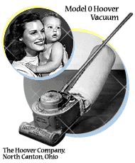

1909
First animated cartoon, Gertie The Dinosaur by cartoonist Windsor McCay.
Selfridges store opens in London
R Peary reached North Pole (USA)

